Detection & Reconstruction:
End-to-End Visual Text Localization and Translation for Images and Videos Using Deep Learning

Project Proposal

By:
Manimeghanath A [23BAI1278]
Shriram Narayanan [23BAI1095]
Koppesh P [23BAI1113]
Department of Computer Science and Engineering- VIT Chennai

- Abstract:
Text embedded within images and videos, such as signboards, posters, and captions plays a critical role in conveying contextual information, yet most multimedia localization systems focus solely on audio dubbing or subtitle generation. As a result, scene text often remains untranslated, breaking immersion for target-language audiences. Existing overlay-based translation methods further fail to preserve visual realism, as they do not reconstruct the original scene.
This project proposes an end-to-end deep learning framework for visual scene text localization and cross-lingual reconstruction in images and videos. The system detects and recognizes scene text in a source language, performs spatially constrained and semantically adaptive translation, reconstructs the background using deep learning based inpainting, and re-renders translated text while preserving visual attributes such as font style, colour, texture, perspective, and temporal consistency. The approach is first validated at the image level as a proof of concept and subsequently extended to short video clips through text tracking and temporal coherence enforcement. Experimental evaluation combines recognition accuracy, translation quality metrics, perceptual similarity measures, and qualitative human assessment to validate visual and semantic fidelity.

- Introduction:
The increasing availability of multilingual digital media has highlighted the limitations of traditional video localization techniques. While audio dubbing and subtitles enable linguistic accessibility, they do not address textual content embedded within visual scenes, such as signboards, posters, and background captions. As a result, essential contextual information often remains untranslated, reducing immersion and comprehension for target-language audiences.
Existing scene text translation methods typically rely on overlaying translated text onto images or video frames. These approaches neither remove the original text nor reconstruct the underlying background, leading to visual artifacts and perceptually inconsistent results. Moreover, direct word-to-word translation can cause spatial misalignment when translated text does not fit the original visual region.
This project addresses these limitations by proposing a deep learning based framework for visual scene text localization and reconstruction. The system aims to translate embedded scene text while preserving visual realism, including font appearance, colour, texture, and spatial alignment. To ensure feasibility, the approach is first implemented on static images as a proof of concept and subsequently extended to short video clips by incorporating temporal consistency constraints.

- Objectives
The primary objectives of this project are:
- To accurately localize scene text regions in images and video frames using deep learning based text detection models to understand the feasibility of the project idea and its proof.
- To recognize source-language text using robust OCR techniques optimized for natural scene conditions.
- To extract geometric and stylistic attributes of scene text, including orientation, scale, colour distribution, and spatial constraints.
- To perform adaptive neural machine translation that preserves semantic meaning while satisfying spatial and visual constraints.
- To reconstruct text-free backgrounds using deep learning–based image and video inpainting techniques.
- To re-render translated text in a visually consistent manner, respecting perspective, texture, and illumination.
- To extend the image-level framework to video by enforcing temporal consistency across consecutive frames.
- To quantitatively and qualitatively evaluate the system’s performance across recognition, translation, and reconstruction stages.

- Scope and Constraints
In-Scope
- Image-level scene text localization and reconstruction as a proof of concept.
- Video-level extension for short clips (5–15 seconds).
- Static or slow-moving scene text.
- Offline processing pipeline.
- Language pair: Telugu → Tamil.
Out-of-Scope
- Poorly Handwritten or heavily cursive text.
- Extreme motion blur or heavy occlusion.
- Real-time or streaming inference.
- Full-length movie processing.

- Proposed Methodology
The project is structured into two progressive phases.
Phase 1: Image-Level Scene Text Reconstruction [ Proof of Concept]
Pipeline Overview
- Scene Text Detection
Detect text regions using convolutional or transformer-based detectors capable of handling arbitrary orientations and varying scales.
- Optical Character Recognition (OCR)
Recognize textual content from detected regions using sequence-based recognition models trained on natural scene text.
- Style and Geometry Extraction
Extract visual attributes such as bounding box geometry, aspect ratio, stroke thickness, dominant colour distribution, and orientation.
- Adaptive Translation Module
Generate multiple candidate translations using neural machine translation models and select the optimal translation based on semantic similarity and spatial constraints.
- Text Removal and Background Reconstruction
Remove original text and reconstruct the underlying background using deep learning–based inpainting models that preserve texture and lighting continuity.
- Style-Consistent Text Rendering
Reinsert translated text by matching extracted visual attributes and geometric constraints to ensure perceptual consistency.

Phase 2: Video-Level Extension [ Complete System ]
Additional mechanisms include:
- Multi-frame text tracking to maintain identity across frames.
- Motion aware inpainting to handle camera and object movement.
- Temporal consistency constraints to prevent flickering and visual drift.
- Frame-to-video reconstruction using standard video synthesis pipelines.

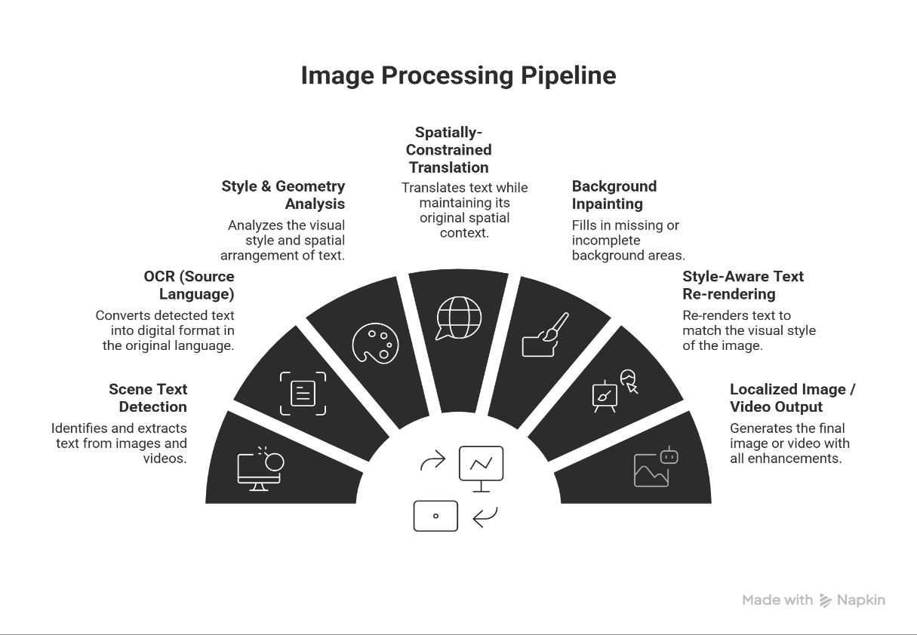
- Project Architecture

- Technologies and Tools:
- Text Detection: CRAFT, DBNet, EAST
- OCR: CRNN, Transformer-based recognizers
- Translation: Transformer-based NMT models
- Inpainting: GAN or diffusion-based inpainting networks
- Frameworks: PyTorch / TensorFlow
- Video Processing: OpenCV, FFmpeg
- Evaluation Metrics and Methodology:
Evaluation is performed at multiple pipeline stages to ensure comprehensive assessment.
8.1 Text Detection and OCR Evaluation
- Precision, Recall, F1-score for text localization.
- Character Error Rate (CER) and Word Error Rate (WER) for OCR accuracy.
8.2 Translation Quality Evaluation
- BLEU Score: Measures n-gram overlap between predicted and reference translations.
- COMET / Semantic Similarity Metrics: Evaluate meaning preservation beyond lexical overlap.
- Spatial Fit Ratio: Measures whether translated text fits within original bounding box constraints.
8.3 Background Reconstruction Evaluation
- PSNR (Peak Signal-to-Noise Ratio): Measures pixel-level reconstruction fidelity.
- SSIM (Structural Similarity Index): Evaluates structural consistency.
- LPIPS (Learned Perceptual Image Patch Similarity): Measures perceptual similarity from a human visual perspective.
8.4 Video-Level Temporal Consistency Evaluation
- Temporal LPIPS: Measures perceptual consistency across frames.
- Flicker Index: Quantifies frame-to-frame intensity variation in reconstructed regions.
8.5 Qualitative Evaluation
- Side-by-side visual comparisons.
- Human perceptual study to assess realism and detectability of translation artifacts.

- Expected Outcome:
- A validated image-level system demonstrating visually realistic scene text translation.
- A video-level prototype maintaining temporal and perceptual consistency.
- Quantitative and qualitative evidence supporting the feasibility of full visual language localization.
- A modular framework extensible to additional languages and domains.

- Application:
- Film and media localization.
- Educational and instructional content translation.
- Tourism and navigation systems.
- Cross-lingual digital accessibility.

- Conclusion:
This project proposes a technically rigorous and modular approach to visual scene text localization and translation, addressing both semantic and perceptual challenges. By integrating scene text detection, adaptive translation, and deep learning–based reconstruction, the system aims to produce images and videos that appear natively authored in the target language, contributing toward more immersive and accessible multilingual media systems.

12. Future Work
- Extension to additional language pairs.
- Handling complex motion and dynamic scenes.
- Joint audio-visual localization.
- Real-time optimization.

